**Software Requirements Specification**

Version 1.3

for

The Force Awakens

Prepared by

|  |  |  |
| --- | --- | --- |
| Nicholas Burdet | 29613773 | nicholas_burdet@hotmail.com |
| Georges Mathieu | 26863477 | gmathieu6@hotmail.com |
| Olivier Cameron-Chevrier | 27228805 | oliver.cc@hotmail.com |
| Stefano Pace | 27454716 | Stefano.pace12@gmail.com |
| Julian Ippolito | 27419112 | julian.ippolito@hotmail.com |
| Adam Trudeau-Arcaro | 27459157 | adamarcaro@gmail.com |
| Joey Tedeschi | 27513062 | joeyg.tedeschi@gmail.com |

|  |  |
| --- | --- |
| Instructor: | Dr. Constantinos Constantinides, P.Eng. |
| Course: | SOEN343: Software Architecture and Design I.  Section H, Fall term, 2016. |
| Date: | November 25th, 2016 |

**Document history**

|  |  |  |  |
| --- | --- | --- | --- |
| **Date** | **Version** | **Description** | **Author** |
| November 12th, 2016 | V1.0 | Preliminary Merging of Documentation Sections | Stefano Pace |
| November 13th, 2016 | V1.1 | Continuation of Merging Documentation Sections | Stefano Pace |
| November 13th, 2016 | V1.2 | Addition of Last section (Analysis Models) | Stefano Pace |
| November 18th, 2016 | V1.3 | Editing Process | Stefano Pace |

**Table of contents**

1. Introduction 4

Purpose 4

Scope 4

Definitions, acronyms, and abbreviations 4

References 5

2. Overall description 6

Product perspective 6

Product functions 6

User characteristics 7

Constraints 7

Assumptions and dependencies 8

3. Specific requirements 8

External interfaces 8

Functionality 13

Actor goal list 13

Use case view 14

Reliability 14

Usability 14

Efficiency 15

Maintainability 15

Portability 16

Design constraints 16

Purchased and Installed Components 17

4. Analysis Models 17

**List of figures**

Figure 1: System Dependency 6

Figure 2: Login Page 9

Figure 3: Login Pop-Up 9

Figure 4: Reservation Table 10

Figure 5: Creating a Reservation 10

Figure 6: Editing Profile Information 11

Figure 7: My Reservations 12

Figure 8: Modify Reservations 12

Figure 9: Use Case Model 14

# Introduction

## Purpose

The purpose of this Software Requirements Specifications Document (SRS) is to outline the capabilities and functionality of the Room Reservation System. This will be accomplished by explaining the goal and characteristics of the system. It will provide further details on system behavior, as well as the system shall do under constraint and how it will respond depending on the user’s actions. This document is addressed to the stakeholders (the students and the staff), the developers and the professors of Concordia University. They are expected to use this document to obtain the requirements of the system.

## Scope

This Software Requirements Specifications document for the Room Reservation System will show how requirements were obtained to build a Web-based System to simplify the process of reserving a study room. It will go on to show how users can make reservations, view reservations, edit profile information, and be placed on a waitlist if the room happens to be full at the selected time slot. Making a simple and effective interface to perform these actions will improve the efficiency of the users allowing them to better visualize and access the rooms required.

## Definitions, acronyms, and abbreviations

|  |  |
| --- | --- |
| **Word** | **Definition** |
| Database | Collection of all the information monitored by this system. |
| Interface | Computer hardware or software designed to communicate information between hardware devices, between software programs, between devices and programs, or between a device and a user. |
| Software Requirements Specification | A document that captures complete description about how the system is expected to perform usually signed off at the end of requirements engineering phase. |
| Stakeholder | A person or group that has an investment, share, or interest in something, as a business or industry. |
| User | Person who uses the system. |

|  |  |
| --- | --- |
| **Word** | **Acronym** |
| Software Requirements Specification | SRS |
| User Acceptance Testing Environment | UAT |
| Production Environment | PRD |

## References

Provide a list of all documents referenced in the SRS.

[1] C. Constantinides, "SRS", 2016.

[2] C. Constantinides, "Requirements Analysis", 2016.

[3] C. Constantinides, "Software Development Processess", 2016.

[4] C. Constantinides, "Software Economics", 2016.

[5] "The Definition of Stakeholder", *Dictionary.com*, 2016. [Online]. Available: http://www.dictionary.com/browse/stakeholder?s=t. [Accessed: 01- Nov- 2016].

[6] "The Definition of Interface", *Dictionary.com*, 2016. [Online]. Available: http://www.dictionary.com/browse/interface?s=t. [Accessed: 01- Nov- 2016].

[7] "Software Requirement Specification", *www.tutorialspoint.com*, 2016. [Online]. Available: https://www.tutorialspoint.com/software_testing_dictionary/software_requirement_specification.htm. [Accessed: 31- Oct- 2016].

[8] “Self-contained system definition” , *www.thefreedictionary.*com, 2016. [Online}. Available: http://www.thefreedictionary.com/self-contained [Accessed 13-Nov-2016].

# Overall description

## Product perspective

A self-contained system is defined as a system which constitutes a complete and independent unit in and of itself. It has no dependency on other systems and is completely self-sufficient [8]. Based on this definition, it can be can concluded that the Room Reservation system is not a self-sufficient system. Whenever a user invokes a feature of the system, the system must perform many queries to the database to check conditions for availabilities, room & user information etc. Therefore, it can be concluded that the system has a direct dependency on the database.

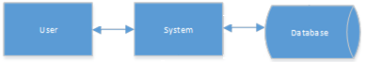

Figure 1: System Dependency

## Product functions

Reserve Function

A user can reserve a specific room at a specific timeslot. If the room is already reserved, then the user is put on a waitlist for the reservation.

If a client wishes to write and the resource is not available (another client is writing on the resource), then the client must wait until the resource becomes available. Writers and readers operate in mutual exclusion. The system may allow multiple readers at a time, however only one writer may make a reservation to a specific room at any point in time. The system must provide safety, liveness and fairness.

Cancel Function

A user can delete a reservation at a specific timeslot for a specific room, as long as they are the user who created the reservation. This is part of the write functions, where only one user can be active at a time.

Waitlist Function

If a reservation is cancelled, the first user on the waiting list for the specific timeslot is given the reservation (if it conforms to all restrictions, i.e the user does not already have 3 reservations for that same week). If the addition of the reservation will make the user obtain their 3rd reservation of the week, then they are consequently taken off any other waiting lists for that same week. This is part of the write functions, where only one user can be active at a time.

Modify Function

A user can modify the timeslot for their reservation in a specific room. This is under the condition that the timeslot the user wants to modify to is available. This is part of the write functions, where only one user can be active at a time.

View Reservations Function

A user can view any reservations or availabilities. This is a read function so multiple users can view simultaneously.

Identification and authentication

When a user attempts to log in, the system will verify the database to see if the username entered indeed exists. If the username is does not exist, then they are told that no account information can be found for their username. If the username is found, then the password will be used for authentication. If the password is confirmed, they will be allowed to access the system. If not, the user is notified the password is wrong and may try again.

## User characteristics

The intended users of the system are students of Concordia University. They are expected to be enrolled in either full-time or part-time courses. Only basic familiarity with the world wide web is expected to be able to use the system. The graphical user interface was made in a very user friendly way, as to provide step by step instructions to the user when he/she wants to use an available feature. As well, all features are available in one concise page.

## Constraints

Since we cannot publicly host our system using public web address, we are limited to opening a port on our server to allow for access. This means we are limited to the following:

* The site will be privately available to only selected students. These users will be sent the link directly to access the website with their credentials.

To properly address fairness, safety, mutual exclusion and data integrity in the system, (so that a user does not reserve too many rooms too often, or does not conflict with another person trying to make a reservation) we will include the following:

* Reservations can only be made once every 30 seconds.
  + A user must wait 30 seconds after attempting to make a reservation before they can make another attempt.
* A specific user cannot have more than 3 reservations a single week period (This is considered on a Monday to Sunday basis).
* A room can be repeatedly booked for up to a maximum of 3 weeks in the future.
* Only one user may access a specific room at any given time in order to create, modify or cancel a reservation.

## Assumptions and dependencies

Several factors that may affect the requirements specified in the SRS include:

* Users of the system are assumed to be (currently) enrolled students of Concordia University. As connecting to an actual student registry is outside the scope of the project, mock accounts are used to validate this assumption.
  + This includes having a premade student account.
* Users are assumed to be using an up-to-date web browser. Though this is unlikely to be an issue for most people, using an outdated web browser may lead to inconsistencies in the user interface, and thus possible changes in the requirements listed.
* This system is dependent on the user having a stable connection to the World Wide Web during usage. Possible cuts in connection could lead to inconsistent storage of user requests, and thus changes in the requirements specified.

*Note: We will only be supporting the following commonly used web browsers: Google Chrome, Firefox, Internet Explorer, Opera, Microsoft Edge.*

# Specific requirements

## External interfaces

This section provides a detailed description of all inputs and outputs from the system. Additionally, a description of the hardware, software and communication interfaces used are provided.

User Interfaces

Upon first accessing the website, the user is greeted by the welcome page (Figure 2). From here, the system allows navigation to my.concordia.ca, as well as providing the user with the option to login.

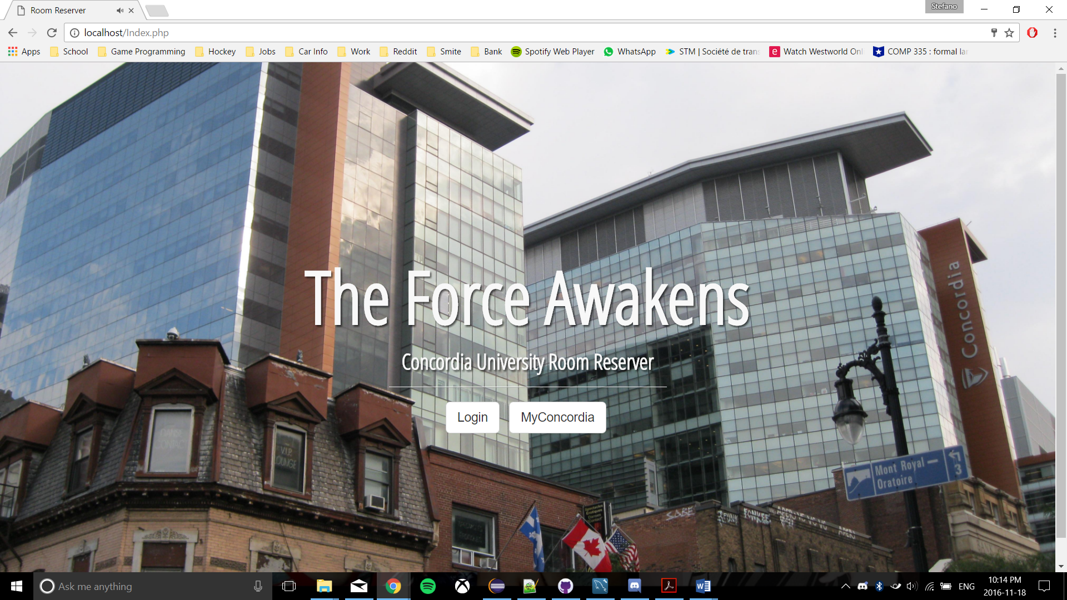

Figure 2: Login Page

Once the user has selected the login feature, a pop-up is generated which accepts the user’s credentials, namely the student’s email and password (Figure 3). If the user’s information is invalid, they are notified as such and can attempt to fix their error.

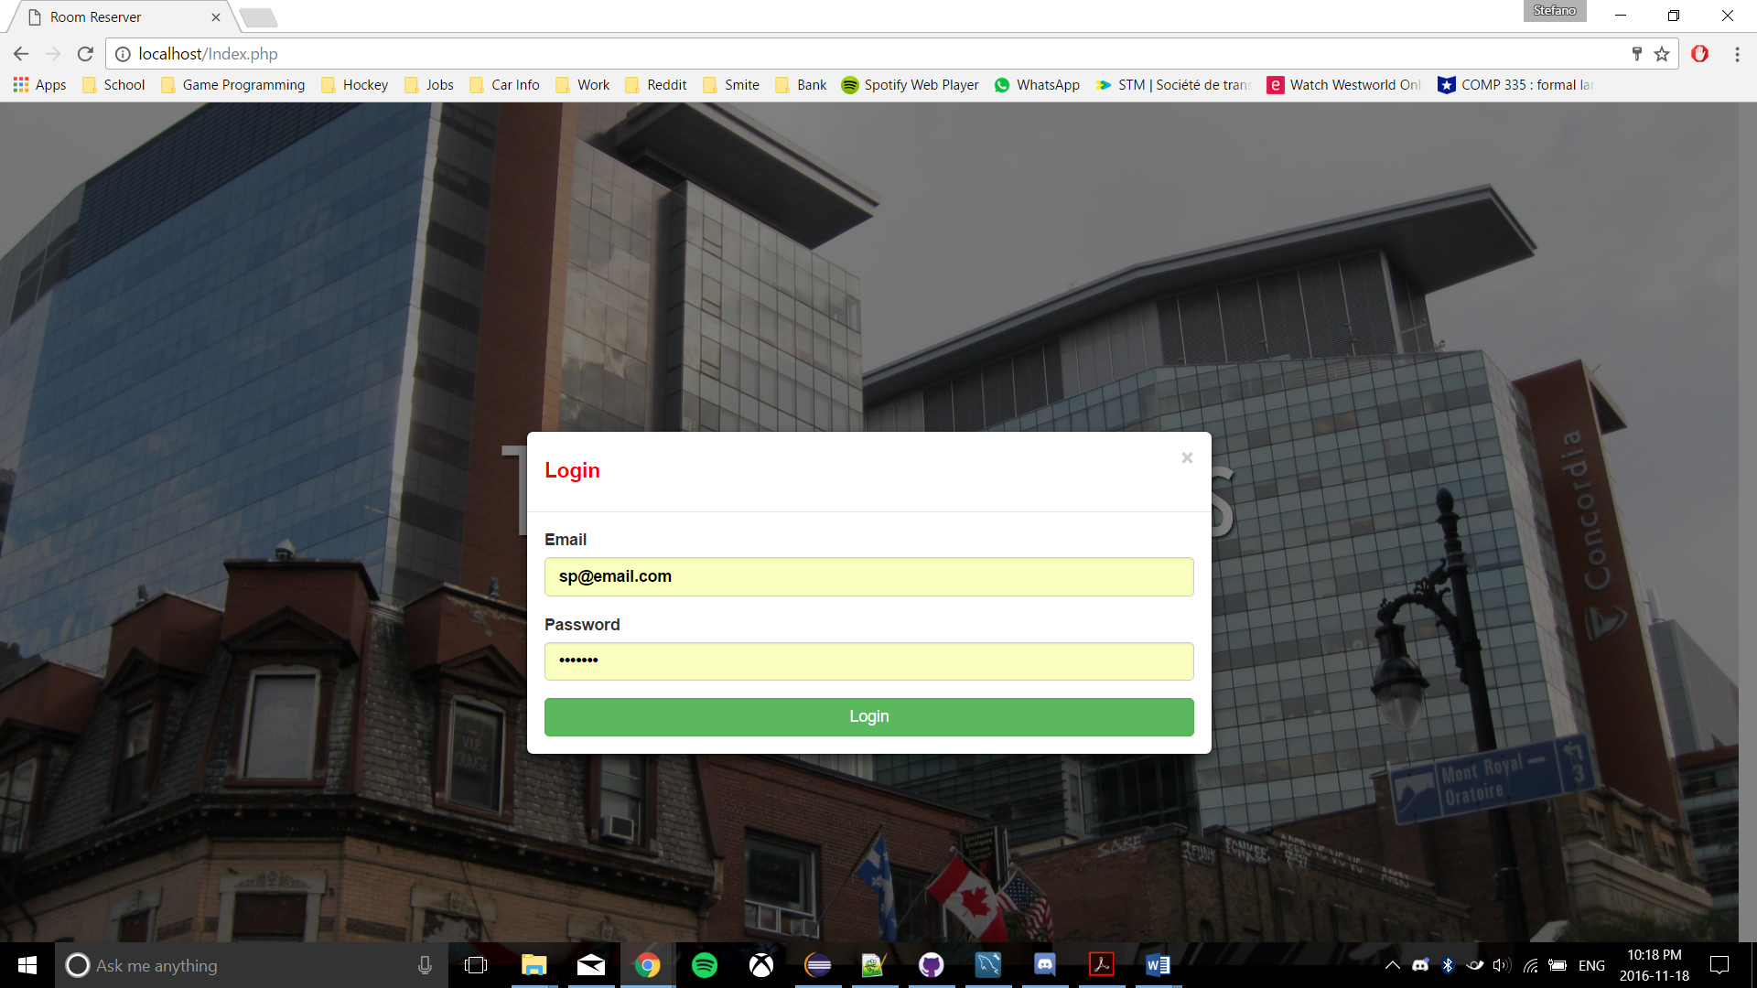

Figure 3: Login Pop-Up

Successfully logging in to the web application will redirect the user to the Reservation page, and they can dictate the exact date they would like to see displayed. Upon selection, a table of times is generated for the user based on the day chosen, including all times currently booked by them, or other students who have used the system (Figure 4).

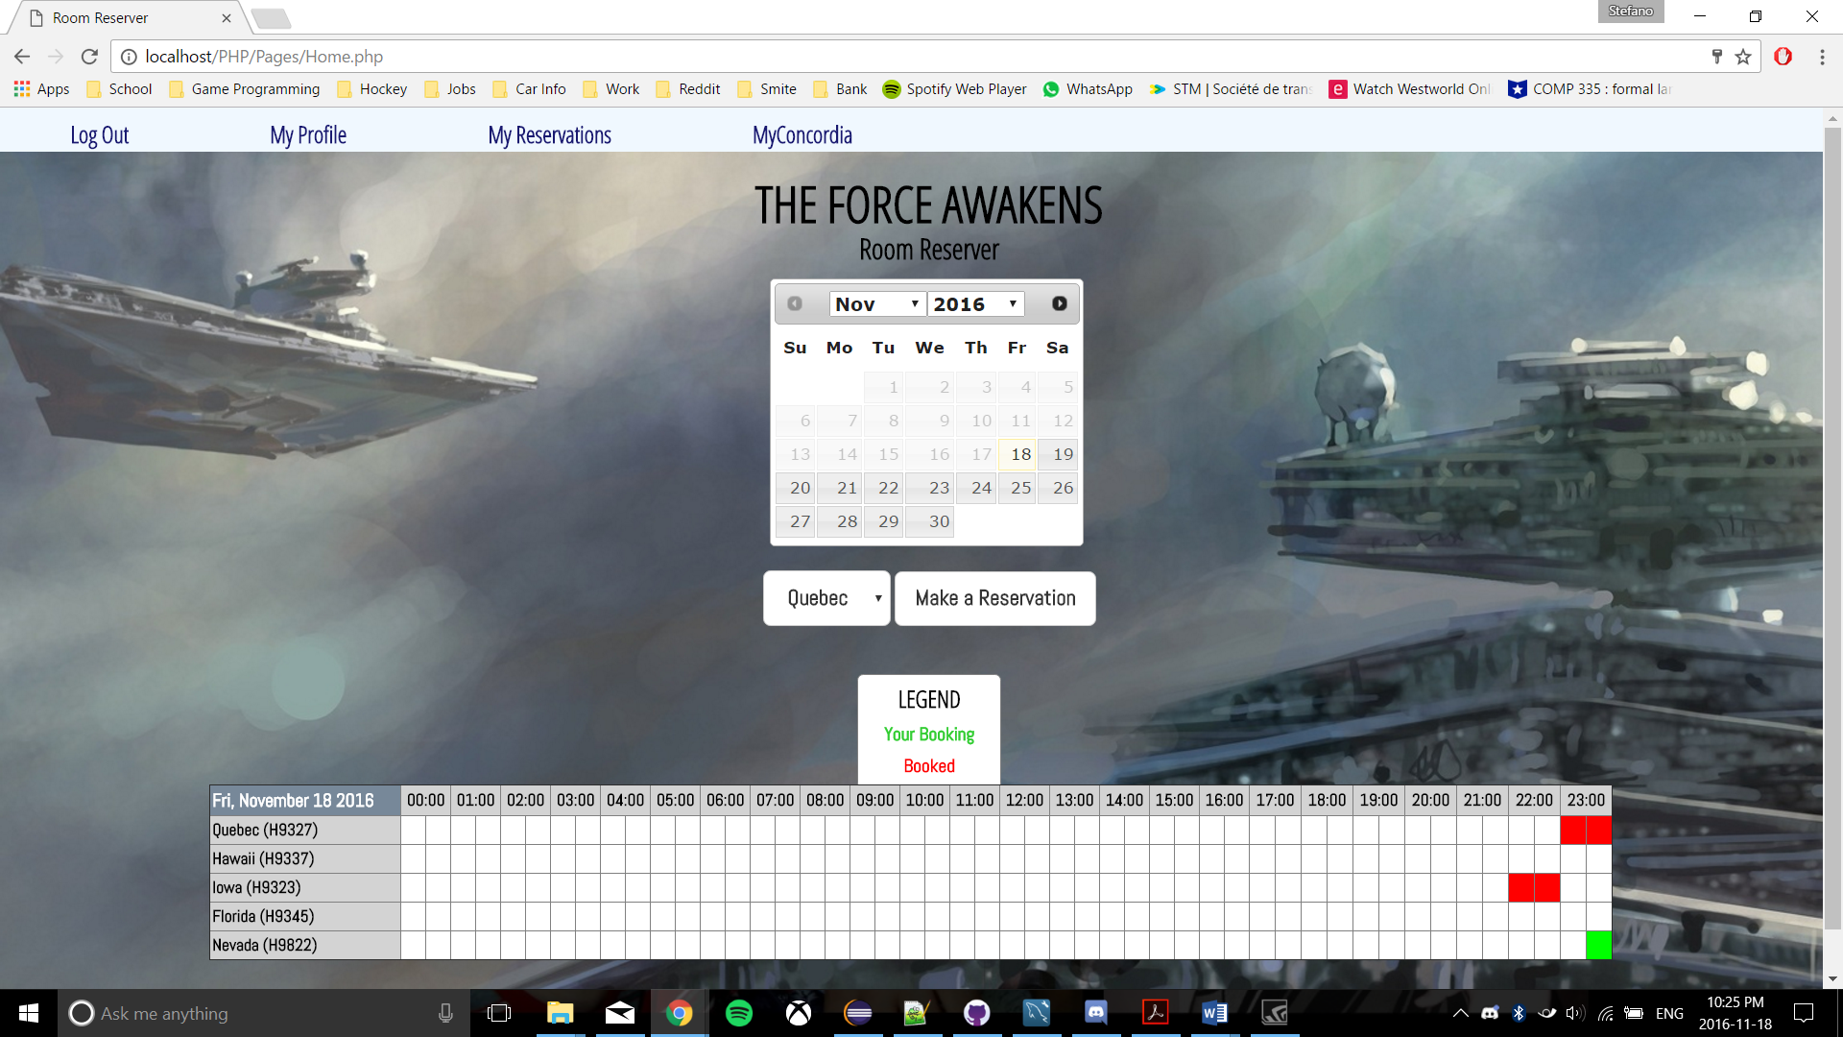

Figure 4: Reservation Table

When they select the room and then the “Make A Reservation” button, the user will be able to then edit the time they would like to book, add a title and descript, and confirm their decision via a pop-up (Figure 5).

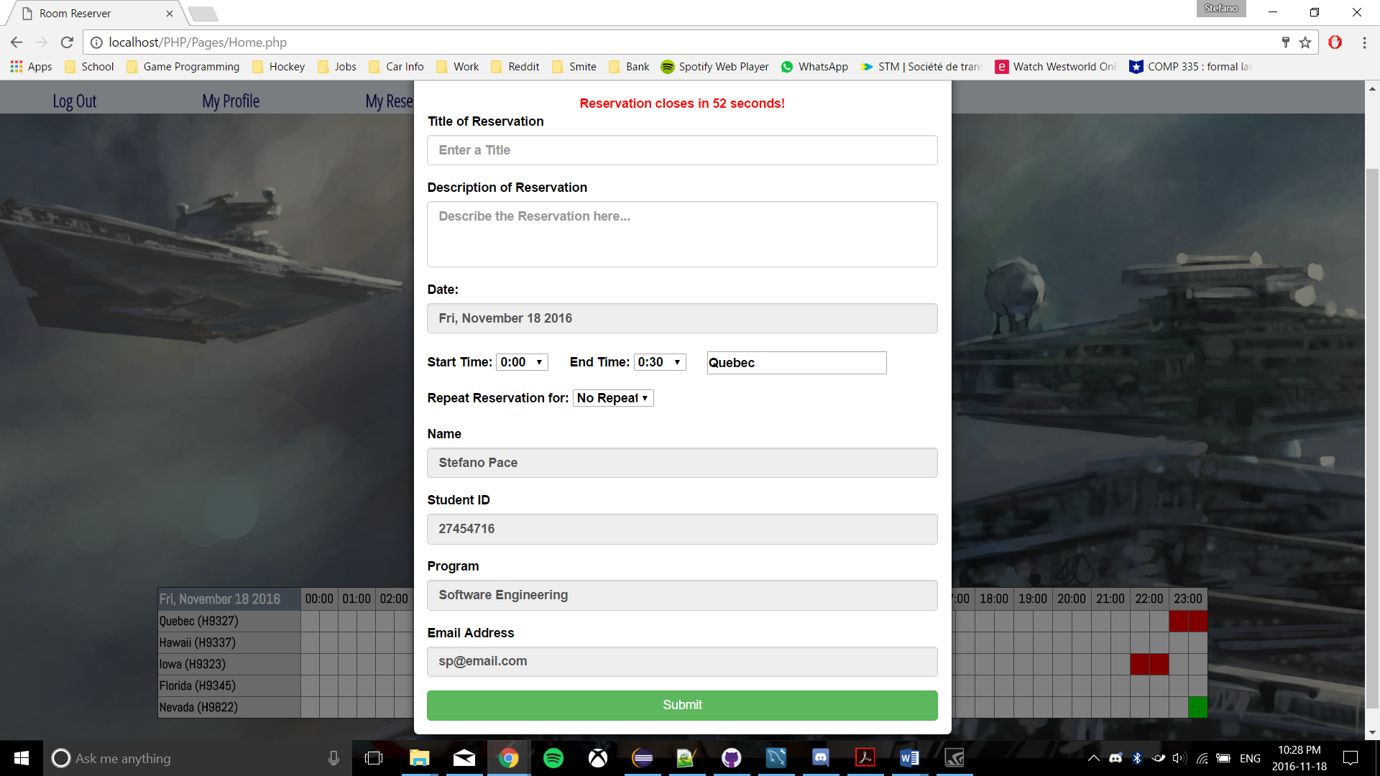

Figure 5: Creating a Reservation

The system allows provides the user with the opportunity to edit their student profile through the “My Profile” option in the upper navigation bar. Selecting this option will display a pop-up, upon which all-current user information will be displayed, thus allowing editing of their password and email (Figure 6).

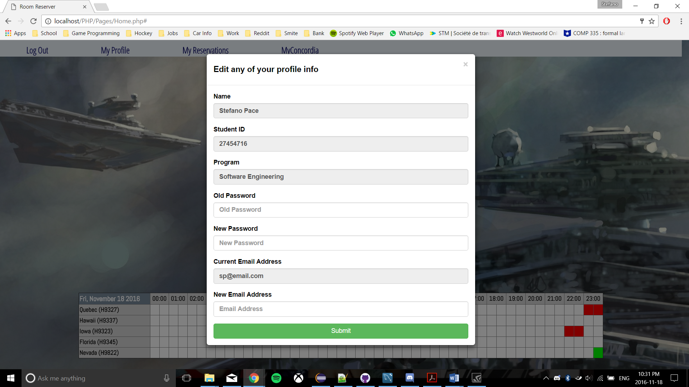

Figure 6: Editing Profile Information

Lastly, the system also provides the user with the option to view their created reservations through the “My Reservations” option in the upper navigation bar. Selecting this option will display a pop-up, where all reservations will display, ordered by date (Figure 7). The user will then have the option to either modify reservations or delete them. When the user selects modify reservation, it will open another pop up that gives the user the option to change the title, description and start/end times (Figure 8).

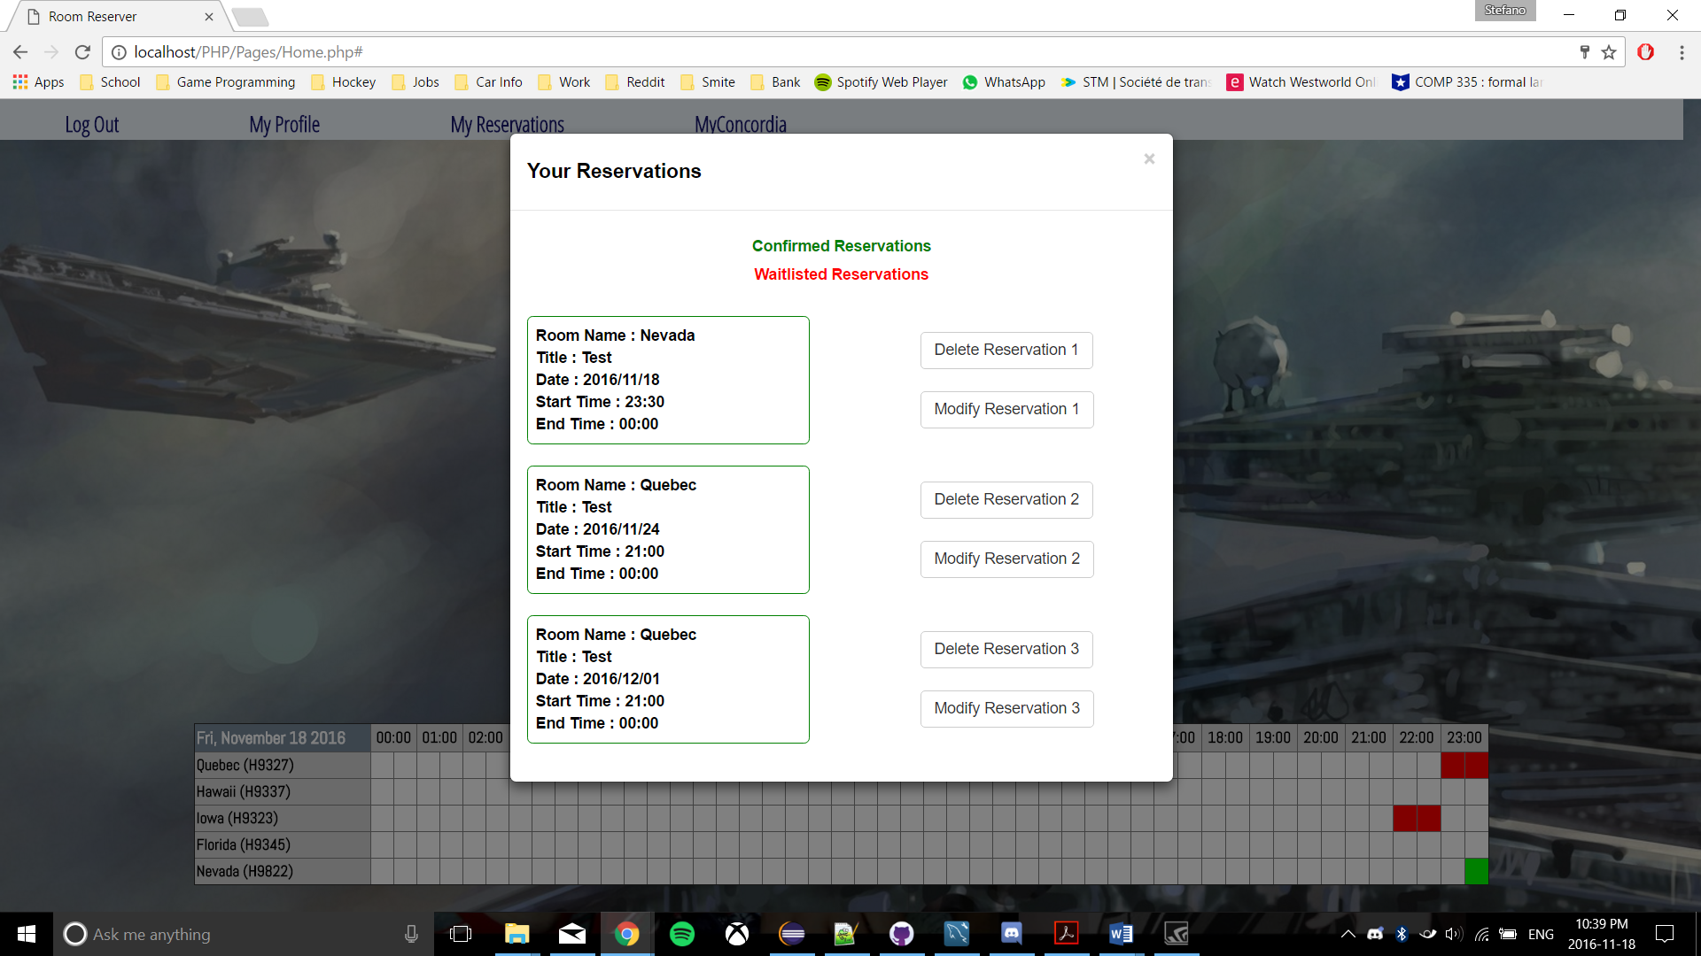

Figure 7: My Reservations

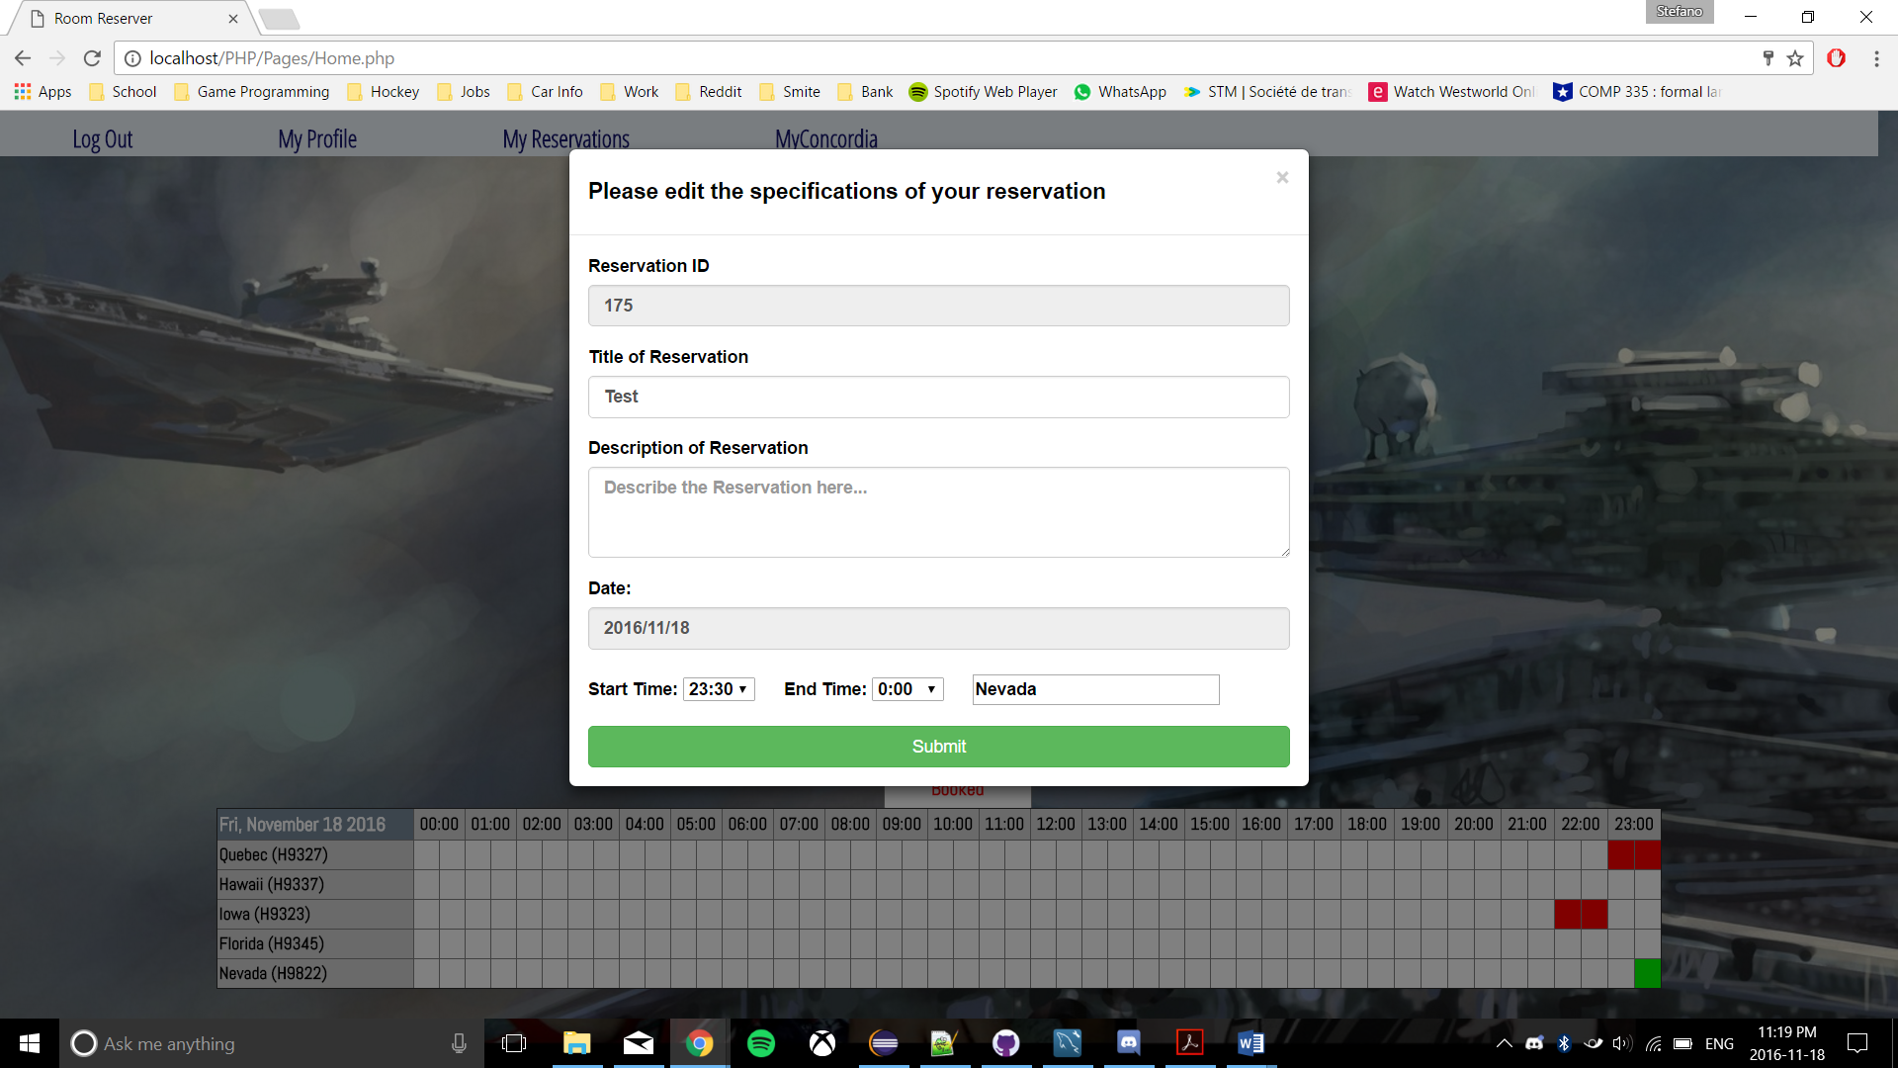

Figure 8: Modify Reservations

Hardware Interfaces

The Hardware Interfaces of the system is summarized plainly by the machine being used to host both the web server and the database. The specification can be found in Purchased and Installed Components section.

Software Interfaces

* Operating System

The Operating System being used by the run-time environment is Windows 7 Professional, which includes Internet information Services (IIS), version 6.1 with PHP 7.0.9.

* Web Server

The website is being designed to run on Internet Information Server version 6.1, with PHP 7.0.9.

* Database

The website accesses Version 5.6.26 of MySQL Community Server (GPL) for the following features:

* + - Retrieving Student Information
    - Updating Student Information
    - Creating and Populating the central reservation table
    - Storing Student Reservation Times
    - Retrieving Student Reservation Times
    - Updating waitlist when reservations are deleted
* Libraries

No external interfaces are to be used for this system with regards to frameworks, as object-relational structural and behavioral patterns are to be manually implemented. With regards to libraries, jQuery is being used to simplify front-end construction, as is Bootstrap (a front-end framework), though this does not compromise the requirements for an object-oriented system.

Communication Interfaces

* Web Interface

The entire reservation system is accessed over the Internet through a web site. As such, all communication between the various parts of the system is done through the web interface provided to the user, allowing their inputs to be translated to various events. This is all done through the use of HTTP protocol.

## Functionality

## Actor goal list

|  |  |
| --- | --- |
| Actor | Goal |
| User/Student | * Log In * Log Out * Make a reservation * Delete a reservation * Modify a reservation * View list of made Reservations * View availability of Rooms * Edit Profile Information |

## Use case view

The use case model is shown in Figure 1.

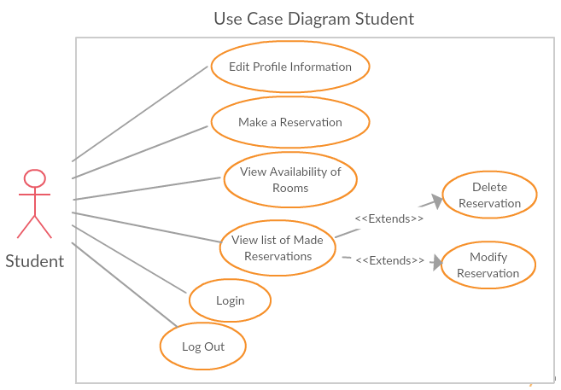

Figure 9: Use Case Model

## Reliability

* The system shall provide for replication of databases to off-site storage locations.

## Usability

Graphical User Interface

* The system shall provide a uniform look and feel between all the web pages.
* The system shall provide a table with all reservations for the user logged in, as well as other users in the system. Different colors will represent these reservations. Green will signify reservations made by the currently logged in user. Red will signify reservations made by other accounts. White will signify available time slots.
* The system shall provide a navigation bar for seamless transition between features.

Accessibility

* Users will be given a 30 second wait time after making a reservation before they are allowed to make another reservation (to allow for fairness).
* Users cannot exist in a single waiting list more than once.
* Users may hold a position in any number of waiting lists for reservations, so long as they have not already reached the maximum number of reservations for the week (currently 3). If they have reached the maximum allotted reservations for the week, they will be removed from all other waiting lists.
* Users holding the top position in a waiting list queue will be given the reservation for that room and timeslot if the current holder cancels their reservation.

*Note: Timeframe and numbers are subject to change upon negotiations*

## Efficiency

For the system to be as efficient as possible, there are 2 criteria which much be considered:

* Acceptable response time
* Number of mouse clicks/redirects needed to get to information or functionality

To achieve an acceptable response time, the system will be constructed so that when a functionality is invoked, it will take **AT MOST** 1 minute (Worst Case Scenario) for the system to process the request. As well, to address the number of mouse clicks needed to get to information or functionality, the system GUI was designed in a way to allow the user access to all features on one simple page. By providing all the features of the system on one page, this will limit the amount of redirects and clicks because the user will not have to search for features, they are all available right after the log in.

## Maintainability

Application Extendibility

Once the final version of the system is completed, it is always possible for more requirements are added later on from the stakeholder. Therefore, the current state of the system should be easily extendable to allow for future requirements to be smoothly integrated into a newer version of the system. The Object Orientation of the system should be implemented in a way that favors the addition of new functions.

Application Testability

In order for the system to be thoroughly tested and vetted before a final version is submitted to the stakeholder, a test environment will be necessary. This test environment will be a separate environment from the live environment. Commonly these are labelled “UAT” and “PRD” respectively. Once a component is validated in the “UAT”, it will then be added to the “PRD” for the stakeholder to verify. As more progress is made in the system, the “UAT” becomes more critical, as when adding new functionality to the system there is always a risk that this make other components unstable.

## Portability

The service is provided to the user via a web page using bootstrap to format the front end & graphical user interface. The framework allows for flexibility and adjustments to the different screen sizes. The web services give our system the flexibility to be run on all machines regardless of the operating system provided there is a compatible browser which is parted of our supported list (See Assumptions and dependencies).

## Design constraints

Standard Development Tools

The system shall be built using a standard web page development tools that conforms to either IBM’s CUA standards or Microsoft’s GUI standards. The languages used will be a mix of the following; HTML, CSS, PHP, JavaScript, Ajax, JQuery, MySQL. As well, bootstrap will be integrated with the system to provide better styling.

Web Based Product

* The use of a dynamically accessible server will be required to store all relevant information from the users, reservations and rooms.
* The computers must be equipped with compatible and supported web browsers (See Assumptions and dependencies)
* Since we cannot publicly host a URL address, users must be sent a direct link to the system (See Constraints).
* Response time for executing features of the system should take no longer than 1 minute in the worst case Scenario (See Efficiency).
* We are assuming that users will have general knowledge of computer skills, therefore we must make the interface as user-friendly as possible and present all features in one concise page (See User characteristics).

## Purchased and Installed Components

During the Implementation and Testing of our system we purchased/installed the following hardware and software.

The server used to host our system, The Force Awakens, has the following hardware specifications:

* + Windows Server 2012 Operating System (64-bit)
  + Quad-Core Processor (i7-4790 CPU @ 3.60GHz)
  + 16 GB DDR2 RAM
  + 25 Mbps Bandwidth
  + 2TB Memory

The Software used on the server will be the following:

* + HTML, CSS, PHP, MySQL (WorkBench)
  + GitHub desktop
  + NotePad++
  + Eclipse
  + Bootstrap
  + Windows 7
  + Microsoft Internet Information Services 7

# Analysis Models

List all analysis models used in developing specific requirements previously given in this SRS. Each model should include an introduction and a narrative description. Furthermore, each model should be traceable the SRS’s requirements.

Analysis Models

1. System Sequence Diagrams

**Figure 1.1 - SSD Authentication**

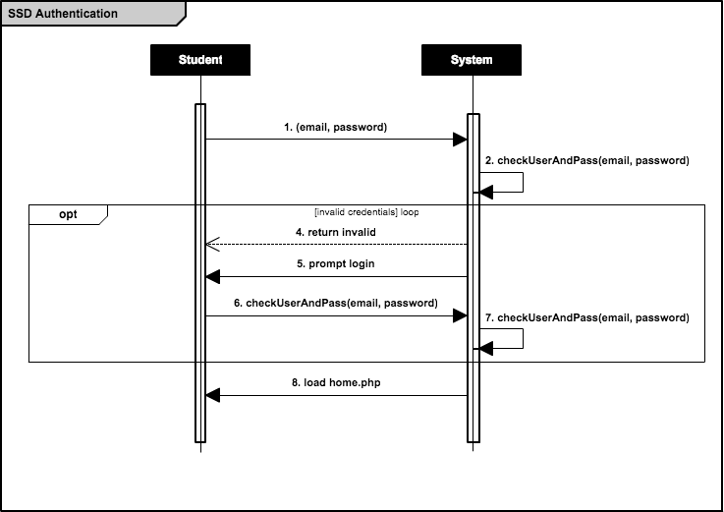

**Figure 1.2.1 - SSD Create Reservation (Booking available)**

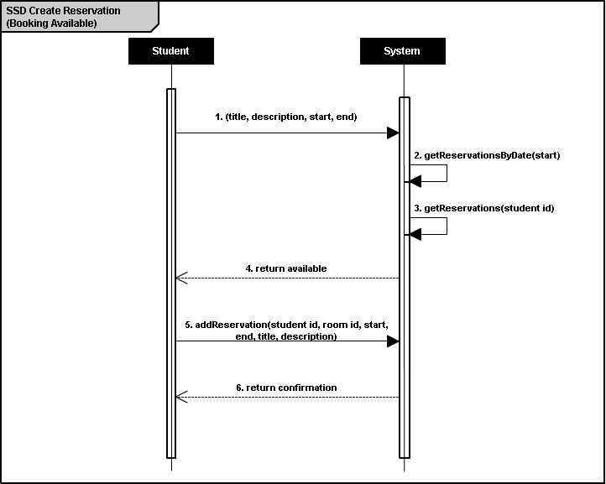

**Figure 1.2.2 - SSD Create Reservation (Booking unavailable)**

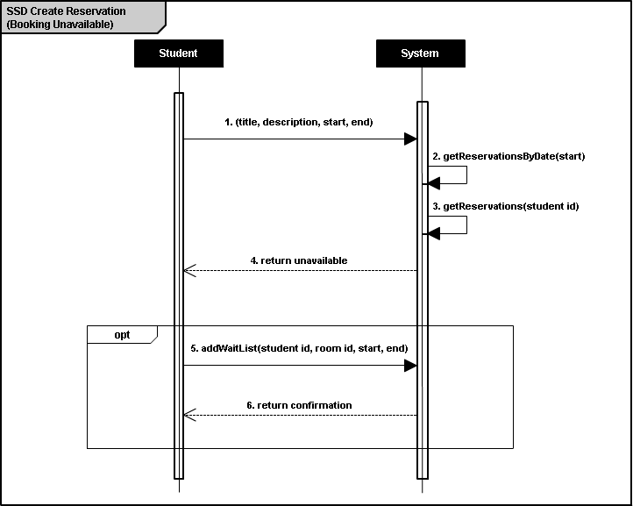

**Figure 1.3 - SSD Cancel Reservation**

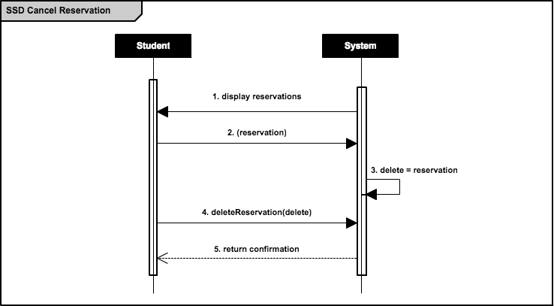

**TEMPORARY Figure 1.4.1 - SSD Modify Reservation (Time)**

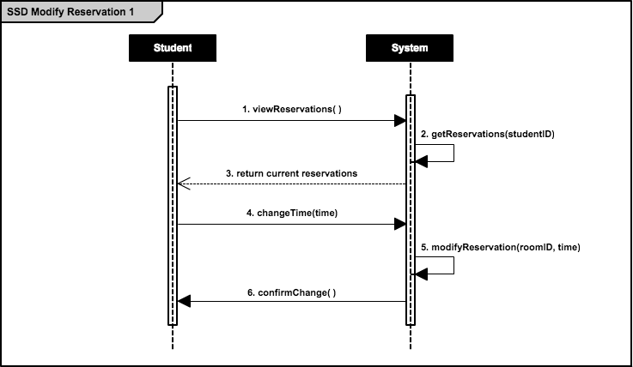

**TEMPORARY Figure 1.4.2 - SSD Modify Reservation (Room)**

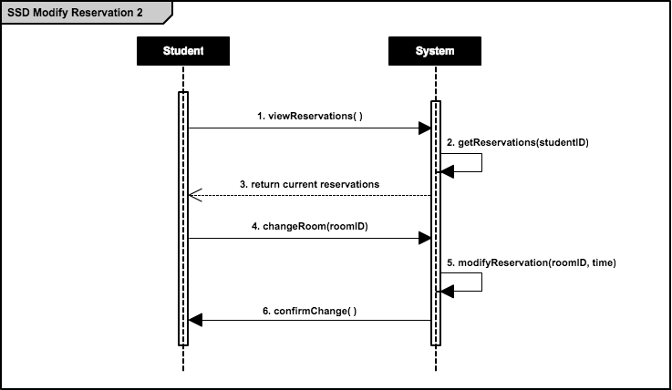

**Figure 1.5 - SSD Change Profile Details**

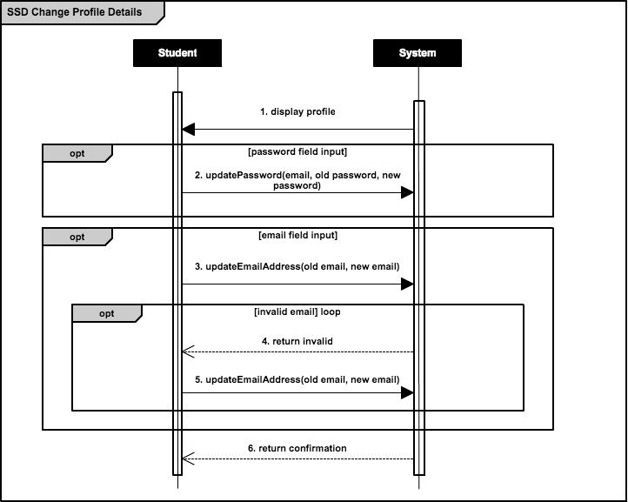

## 2. Operation Contracts

**Figure 2.1 - OC Check Username and Password**

|  |  |
| --- | --- |
| ***Operation Contract 1*** | **Check Username and Password** |
| *Contract* | checkUsernameAndPassword |
| *Operation* | checkUserAndPass(email, password) |
| *Cross-Reference* | Check Username and Password Use Case |
| *Pre-Conditions* | * User has successfully connected to authentication server * User has existing account with valid credentials * User has entered said credentials |
| *Post-Conditions* | * Instance of StudentMapper has been created * Instance of ReservationMapper has been created * Account information has been associated with session |

**Figure 2.2 - OC Add Reservation**

|  |  |
| --- | --- |
| ***Operation Contract 2*** | **Add Reservation** |
| *Contract* | addReservation |
| *Operation* | addReservation(student id, reservation id, start, end, title, description) |
| *Cross-Reference* | Add Reservation Use Case |
| *Pre-Conditions* | * User account has been authenticated (see *Figure 2.1*) * User has selected a valid room, start time, end time, date combination * User has entered a valid title and description * User has less than 3 existing reservations in that week |
| *Post-Conditions* | * Reservation has been associated with database * Student has been associated with reservation |

**Figure 2.3 - OC Add to Waiting List**

|  |  |
| --- | --- |
| ***Operation Contract 3*** | **Add to Waiting List** |
| *Contract* | addToWaitingList |
| *Operation* | addWaitList(student id, reservation id, start, end) |
| *Cross-Reference* | Add Reservation Use Case |
| *Pre-Conditions* | * User account has been authenticated (see *Figure 2.1*) * User has selected an invalid room, start time, end time, date combination * User has less than 3 existing reservations in that week |
| *Post-Conditions* | * *reservation.isCreated* has been set to *true* * *reservation* has been associated with *student* |

**Figure 2.4 - OC Update Password**

|  |  |
| --- | --- |
| ***Operation Contract 4*** | **Update Password** |
| *Contract* | updatePassword |
| *Operation* | updatePassword(email, old password, new password) |
| *Cross-Reference* | Update Password Use Case |
| *Pre-Conditions* | * User account has been authenticated (see *Figure 2.1*) * User has entered a valid old password * User has entered a valid new password |
| *Post-Conditions* | * New password is associated with student |

**Figure 2.5 - OC Update Email Address**

|  |  |
| --- | --- |
| ***Operation Contract 5*** | **Update Email Address** |
| *Contract* | updateEmailAddress |
| *Operation* | updateEmailAddress(old email, new email) |
| *Cross-Reference* | Update Email Address Use Case |
| *Pre-Conditions* | * User account has been authenticated (see *Figure 2.1*) * User has entered a valid new email address |
| *Post-Conditions* | * New email address is associated with student |

## 3. Domain Model

**Figure 3 - Domain Model**

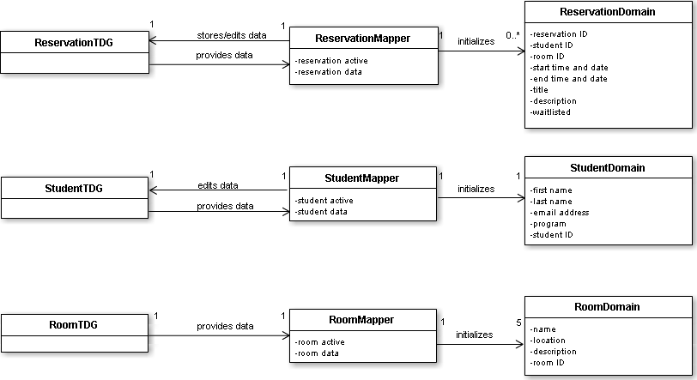

## 4. Use Cases

**Figure 4.1** **- System Use Case**

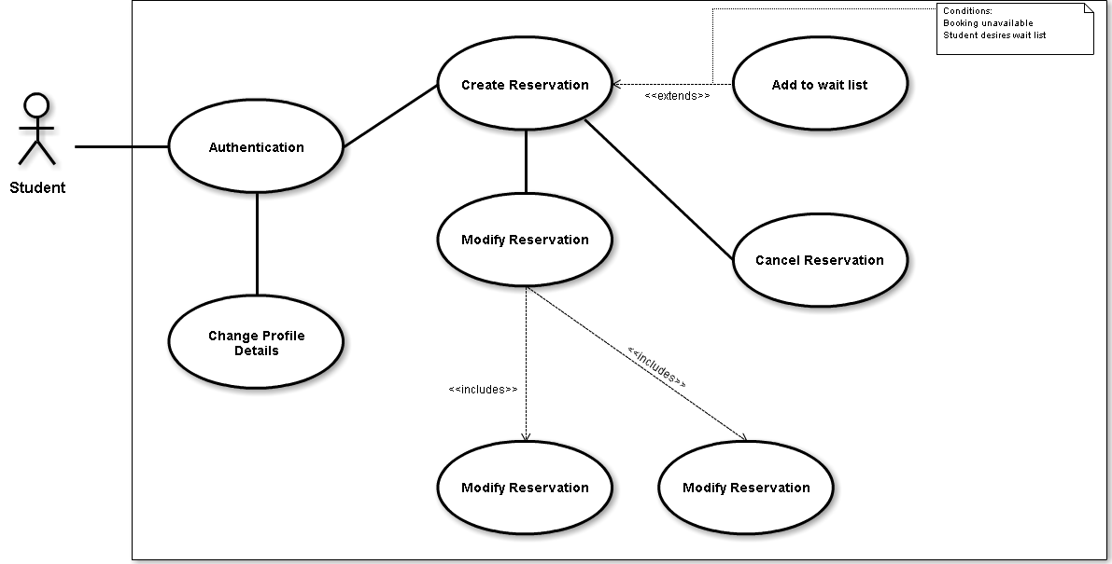

**Figure 4.2 - Check Username and Password Use Case**

|  |  |
| --- | --- |
| ***UC1*** | **Check Username and Password** |
| *Actor* | Student |
| *Goal* | Verify validity of email and password combination |
| *Summary* | Student must enter their valid credentials before being authenticated into the system |
| *Preconditions* | * Student accesses index site |
| *Steps* | * Student enters email address * Student enters password * System verifies credentials in database * System loads home page |
| *Postconditions* | * Student has been authenticated into home page |
| *Extensions* | Student enters invalid credentials, and is prompted to try again |

**Figure 4.3 - Add Reservation Use Case**

|  |  |
| --- | --- |
| ***UC2*** | **Add Reservation** |
| *Actor* | Student |
| *Goal* | Add reservation associated with authenticated student |
| *Summary* | Student selects reservation information and creates a room reservation under their name |
| *Preconditions* | * Student has been authenticated |
| *Steps* | * Student selects “Make a Reservation” * System displays reservation form * Student enters a title and description * Student selects a room and time * Student submits form * System verifies if title and description are valid * System verifies if room and time are available * System verifies if student already has 3 reservations booked in that week * System associated reservation with student * System displays confirmation |
| *Postconditions* | * Student account now associated with reservation |
| *Extensions* | If room and time combination are already booked, add reservation to waiting list |

**Figure 4.4 - Update Password Use Case**

|  |  |
| --- | --- |
| ***UC3*** | **Update Password** |
| *Actor* | Student |
| *Goal* | Change current password for authentication |
| *Summary* | Student accesses their profile and enters current and desired password for change |
| *Preconditions* | * Student has been authenticated |
| *Steps* | * Student selects “My Profile” * System displays profile information * Student enters current password * Student enters desired password * Student submits form * System verifies if old and new passwords are valid * System changes student password * System displays confirmation |
| *Postconditions* | * Student password changed |

**Figure 4.5 - Update Email Address Use Case**

|  |  |
| --- | --- |
| ***UC3*** | **Update Email Address** |
| *Actor* | Student |
| *Goal* | Change current email for authentication |
| *Summary* | Student accesses their profile and enters desired email address for change |
| *Preconditions* | * Student has been authenticated |
| *Steps* | * Student selects “My Profile” * System displays profile information * Student enters desired email address * Student submits form * System verifies if new email address is valid * System changes student email address * System displays confirmation |
| *Postconditions* | * Student email address changed |